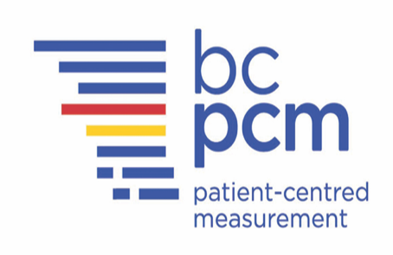

Personas to Support Health Care Provider Use of Electronic Patient-Reported Outcomes in the Care of Older Adults with Cancer

Research Study Information

What is the purpose of the research?
This research will help to create “personas” which are hypothetical representations, in this case, of older cancer patients that incorporate demographic data and fictional life stories. You are being invited to help develop patient personas to assist your health care providers to better understand the medical, emotional and social needs of older cancer patients. The patient personas will then be used as tools to inform the development of a learning module for health care providers on the use of electronic patient-reported outcomes in the care of older adults.

Who is conducting the research?
Principal Investigator: | Dr. Jae-Yung Kwon is a registered nurse and an Assistant Professor at the University of Victoria  Phone: 604-729-2308 Email: jykn1@uvic.ca
How can you help?
If you are an older adult (65+ years of age) who is living with cancer and would like to take part in this study, you will be asked to participate in one-and-a-half-hour online workshop session (and a follow-up feedback survey) in the development of personas to help health care providers better manage the cancer journey of patients. Please note that your care at BC Cancer will not be compromised should you elect not to join the study.

Please contact the researcher or the research assistant Melissa moyniha3@student.ubc.ca if you think you might like to take part in this study.

